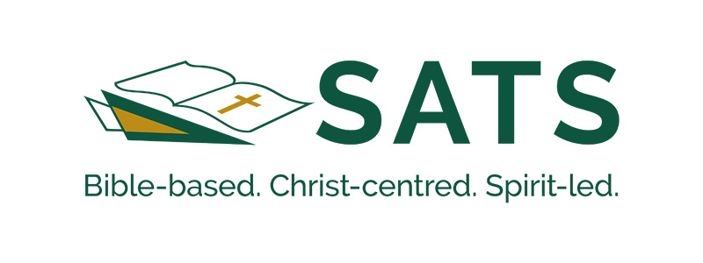

Conspectus Author’s Agreement

Before submitting your article for review, please read and sign the below agreement.

General

I agree that
- the article is submitted with the consent of all the authors/contributors and other relevant parties;
- the article includes the necessary citations, is not plagiarized, and does not infringe on any copyright laws;
- consent has been given for the inclusion of all tables, figures, or images used;
- the article has not been published elsewhere; and
- the article is not undergoing review for possible publication with another journal.

Plagiarism

I am aware that
- The Conspectus Editorial Team considers plagiarism (whether intentional or unintentional) a serious offense;
- if I am found guilty of significant or pervasive plagiarism, am a repeat offender, or refuse to meet with the Editorial Team if my article is flagged for potential plagiarism, the editors reserve the right to inform my superiors and enforce a permanent ban on any submissions;
- if I am found guilty of unintentional or isolated plagiarism, my article will be removed from the upcoming volume, and I will be banned from submitting anything for a year.

Review

I take cognizance of
- the journal’s high view of Scripture, as is consistent with evangelical tenets and that publishing articles that employ reader-centered methodologies for exegesis does not lie in Conspectus’s purview;
- Conspectus’s double-blind peer review process. Should I wish to appeal the outcome of a review, I will contact the journal editor who will consider the case alongside the Editorial Team. Once the appeal has been processed, the decision made by the Editorial Team is final.

Publication Fee

- I take cognizance of the article fee of 4500 ZAR, payable after publication by authors who are formally affiliated with a South African public university and hence benefit from the subsidy provided by the South African government.

Author’s name: Date:

_________________
Signed

